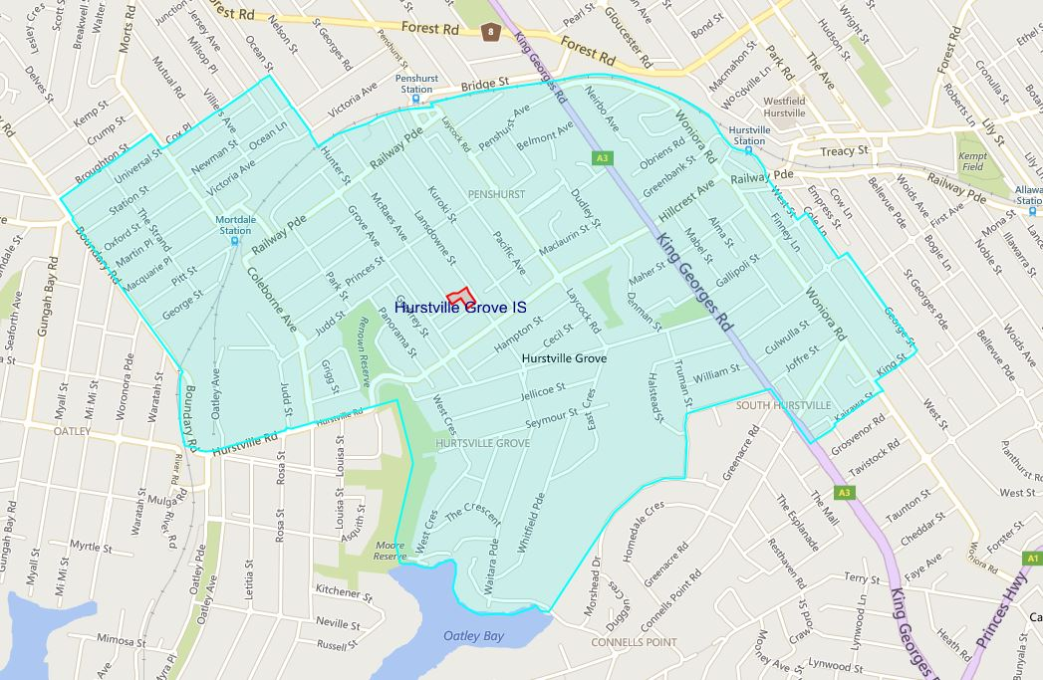

**Hurstville Grove Infants School – Catchment Area Map**